

BATCH AND ROLL NO:
EXPERIMENT NO.1
TITLE: Install Android studio. Create Hello World app.
DATE OF PERFORMANCE
DATE OF CHECKING

Title: Install Android Studio. Create Hello World app.

Requirements:
1 Android studio
- Java SDK

Theory:

  - Android studio is one of best program for Android app development.
  - It offers a plethora of features and integrated tools for creating a professional Android apps.
  - The program includes a features rich Android emulator, testing tools and consistent development environment. In addition to this it also features an intelligent code editor that provides you with advance code suggestions.
  - Due to many configuration steps, Android Studio may be challenging to set up if you're a novice developer. Here, we show how to install Android Studio on Windows and create a sample application.

Java JDK

  - Before installing Android Studio, you first need to install the Java JDK and set up the Java environment to start working on it.
  - The Java Development Kit (JDK) is a required development package for creating Java- based applications. Additionally, it also includes tools for developers for testing Java- coded applications.



Follow these steps to get the latest version of Java JDK for Windows and set it up:

- Go to the official Oracle Java Downloads page.
- Choose the most recent version of Java JDK and download the x64 MSI Installer under the Windows tab.
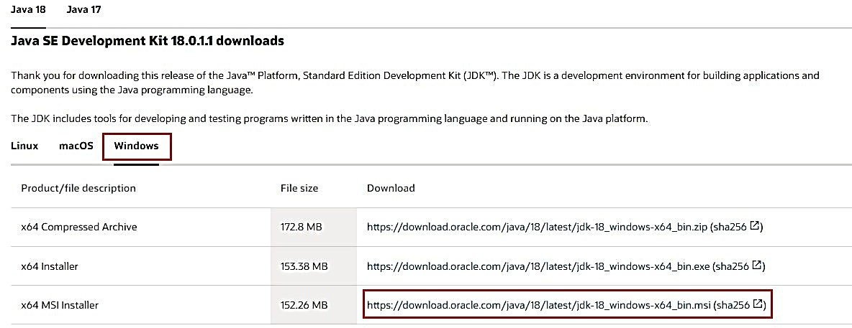

- Open the file you've just downloaded from the Downloads folder.
- Follow the on-screen instructions to install the latest Java JDK.

Once JDK installed successfully, next step is to set up a Java environment so that Android Studio can easily find the location of Java on desktop.



Steps for Setting Up the Java Environment

- Open Windows search and type "Edit environment variables."
- Hit the Enter key to open the Environment Variables window.
- Now, under the System variables section, click Path > Edit > New
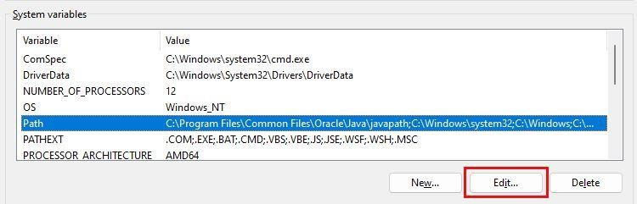

- Copy the path of the folder where the JDK binaries are installed. For example, in our case, the path is C:\Program Files\Java\jdk-18.0.1.1\bin.
- Switch to the Environment variables window and paste the path you've copied and save the changes.
- Next, under the User Variables section, click New.
- Add PATH_HOME in the variable name box and C:\Program Files\Java\jdk-
18.0.1.1 in the variable value box.
- Finally, save the changes by clicking OK.

NOTE: [In general, you do not need to reconfigure any environment variables if you have already done so. But if it's your first time, setting the variables will help you reduce Java-based errors during compilation.]



Steps to Install Android Studio on Windows

- Visit the Android Developers website and click on Download Android Studio.

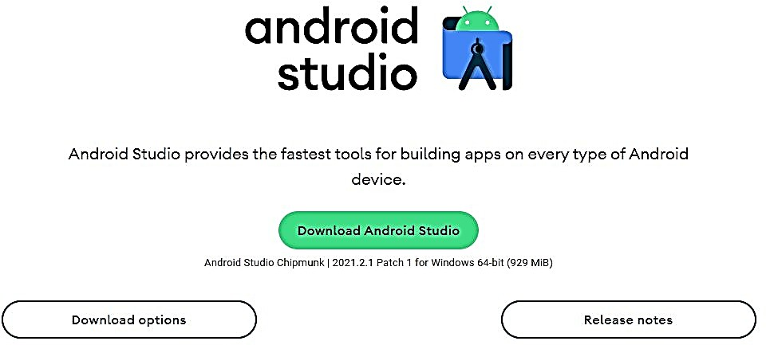

- Now, open the downloaded file to install Android Studio.
- Click Next to continue installing Android Studio.
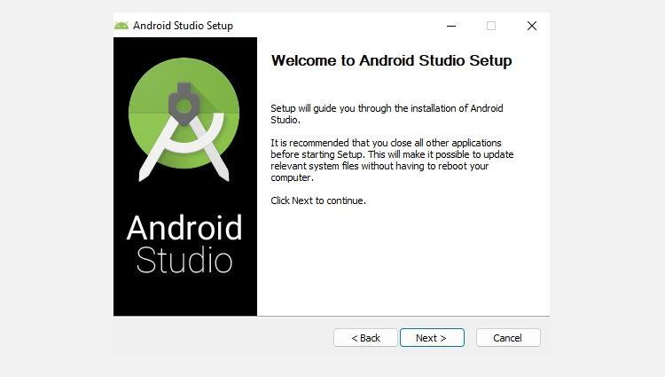

- Further, click Install and wait while Android Studio is being installed on your PC.
- Once done, click Finish to close the installer and start Android Studio.
- Android Studio will now ask you to import settings. Click OK to continue to set up Android Studio.



The System Requirements for Android Studio on Windows

Your PC must meet the following requirements to run Android Studio efficiently:

  - 64-bit Microsoft Windows OS 8/10/11.
  - 1280 x 800 minimum screen resolution.
  - x86_64 CPU architecture; 2nd generation Intel Core or newer; or AMD CPU with Hypervisor support.
  - 8GB of RAM or more.
  - 12GB of available disc space is required (IDE + Android SDK + Android Emulator).



CONCLUSION:

……………………………………………………………………………………………

……………………………………………………………………………………………

……………………………………………………………………………………………

SAMPLE OUTPUT:




